**INF211**

**THE PROJECT OF THE CONDITIONAL STATEMENTS**

**PROJECT-4**

**PROJECT-4:** **Mathematical operation, variables, printf/scanf, if, else, else if commands in C**

**Deadline is November 13, 2020 at 23:00.**

**Projects that are not delivered on time are not accepted.**

**Upload the project to the Project 4 assignment section of the INF211 class.**

**The questions can be asked to course lecturer Dr. Tuba Gözel and teaching assistant Suleyman TUNCEL under the Project 4 announcement of INF211 class Week4 channel.**

**The questions should be programmed with C codes. The code filenames should be formatted as ID_N_P4_Q#.C**

***Note:***

* ***Do not forget to write the meaning of what you do in the code as a comment.***
* ***You must send the code files.***
* ***Code Filename should include school ID, the first letter of student’s whole name (registered name in the student information system), Project Number and Question Number.***

***Filename format should be* ID_FirstLetterofName_P#_Q#**

***Example: The code filename of Veli Zeki Doğan for question 1 should be* 201029999_VZD_P4_Q1.C**

1. The equivalency table of the grading system is in the Table-1. For the grades are given in the Table-2, please draw a flowchart and write a program that finds the letter grade equivalent.

Table 1 The equivalency table

|  |  |
| --- | --- |
| Percent grade | Letter grades |
| 90-100 | AA |
| 80-89 | BA |
| 75-79 | BB |
| 70-74 | CB |
| 65-69 | CC |
| 60-64 | DC |
| 50-59 | DD |
| 40-49 | FD |
| 39 and below | FF |

Table 2 Grades Table

|  |  |
| --- | --- |
| Grade-1 | 95 |
| Grade-2 | 88 |
| Grade-3 | 72 |
| Grade-4 | 52 |
| Grade-5 | 42 |
| Grade-6 | 17 |

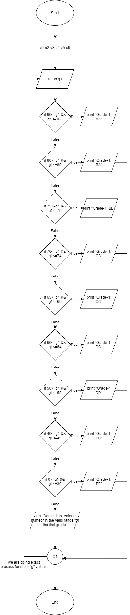

1. The elements of 3 Sets are given below. Please draw a flowchart and write a program that finds A∩B∩C and A∩B\C .

A={1,2,3,4}

B={2,4,11,12}

C={2,4,10,14}

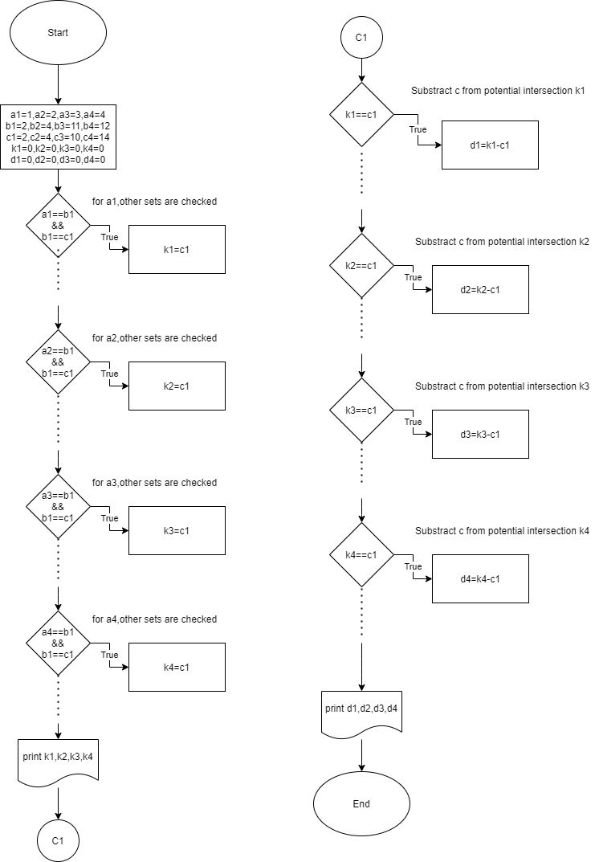

3) Please draw a flowchart and write a program that finds the years divisible to 4 between the years of 2010 and 2100.

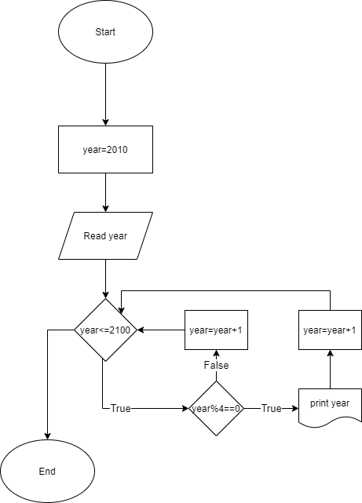

Note: Please use **If and if-else** conditional statement functions in your code.